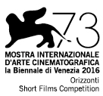

COLOMBI

a film by Luca Ferri
Italy 2016, 20’ (b&w, col.)

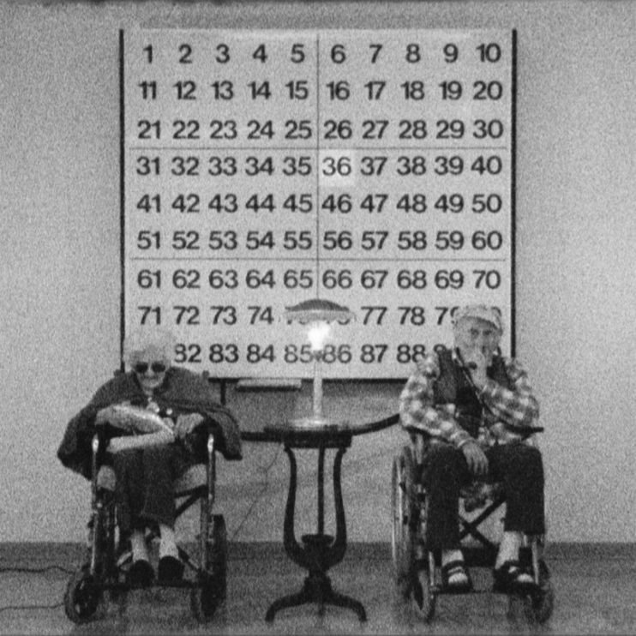

produced by


PRESS MATERIALS
www.lab80.it/pressarea

PRESS OFFICE
Sara Agostinelli
+39 329 0849615 +39 035 342239 +39 035 5781021
press@lab80.it www.lab80.it

SYNOPSIS
A loving couple spends a century together, while trends, objects and films slowly drift into horror. They will be obsessed with octagonal knobs of coffee pots and anonymous design all of their life. They will age and slowly lose their strength, but they will never lose clarity of thought excluding the outer world, darkening and shuttering their house and withdrawing into themselves, leafing through old encyclopedias about extinct animals.

DIRECTOR’S NOTES
Colombi is a reflection on the last century and two people's precise unwillingness to accept the changes imposed by society. The film tells us about a pure feeling like love and leads us into an intimate universe made of small gestures and radical choices, in which isolation is the only way to survive.
Luca Ferri

THE DIRECTOR
Luca Ferri (Bergamo, Italy, 1976) works on images and words. Self-taught, since 2011 he has been dedicating to writing, photography and direction of films that has been screened at Italian and International Festivals. His first feature film Abacuc, released in 2015, was presented at Torino Film Festival and Festival de Cine de Mar del Plata, Argentina.

FILMOGRAPHY
Magog [o epifania del barbagianni], 2011, 66’
Kaputt/katastrophe, 2012, 14’
Ecce ubu, 2012, 60’
Habitat [piavoli], 2013, 61’
Caro nonno | Dear Grandpa, 2014, 18’
Abacuc, 2014, 83’
Ridotto mattioni | Mattioni reduced, 2014, 10’
Curzio e marzio, opera picaresca in due atti di Dario Agazzi cinematografata da Luca Ferri, 2014, 45’
Tottori, 2015, 6’
Cane caro | Dog, Dear, 2015, 18’
Una società di servizi | A Society of Services, 2015, 30’
White out, 2016, 7.25’

FILM INFORMATION

DIRECTION AND SCRIPT: Luca Ferri
EDITING AND POST PRODUCTION: Stefano P. Testa
PHOTOGRAPHY AND SHOOTING: Pietro De Tilla, Giulia Vallicelli, Andrea Zanoli
AUDIO RECORDING AND MIX: Giulia La Marca
FILM DEVELOPMENT AND CONVERSION: Giulia Vallicelli, Giulia Castelletti, Alessandra Beltrame
SCENE OBJECTS ADVICE: Pietro De Tilla, Alberto Zordan, Antichità San Marco Milano
PRODUCTION: Lab 80 film, ENECE film
PRODUCTOR: Andrea Zanoli
GRAPHIC DESIGN: Leo Colalillo, Arianna Milesi
TRANSLATION: Martina Gomes, Marta Cesari, Roberta Sana
COUNTRY: Italia
YEAR: 2016
DURATION: 20’

CAST
Annunciata Decò (herself)
Giovanni Colombi (himself)
Dario Bacis (himself)

NARRATOR: Assila Cherfi

INTERVIEW TO LUCA FERRI

Luca Ferri, you define the main characters of the film “a loving couple”. Why is Colombi a love story? Could it be also read as the story of a shared unhappiness?
Colombi is a film about love and partly tells what Ingmar Bergman narrated in the film Vargtimmen (The hour of the wolf) when Alma Borg says: “A woman who lives for long with a man ends up becoming like him. It is said that if she loves and tries to think and see like him, she finally identifies with him, as he becomes like her. Two people who have lived all of their life together end up being similar. Making experiences together changes not only the thoughts but also the faces, that in the long term will have the same expression”. Colombi is the story of a symbiosis and a precise and radical choice: not wanting to adapt to changes and isolating from the world. In all of this desperation there are also sweet and happy moments. The film swings between these elements, only apparently opposite.

Time passing by is associated with the description of the change of the common use objects over the decades and with the relationship the couple has with them. Is there any symbolic sense in referring to those objects?
Objects have a symbolic and chronological meaning. They are an extreme synthesis and describe an era better than thousands of detailed words. The proliferation of plastic scooters instead of metal geared motorcycles and the lost beauty of anonymous objects replaced by authors designs are only some of the elements the narrator recounts as a degenerative process of the current time, to which the main characters oppose with a silent and calm attitude. Colombi, finally, also tells us about how we lost the ability to use things until they are worn out, changing them dizzily at their first problem.

Like in the past, you chose to shoot Super 8. Why?
I decided to shoot Super 8, as in Abacuc, because I wanted to represent the body of Dario Bacis by means of a living support, avoiding digital shooting that would squeeze him and lose the power and the gracefulness of his rounded metaphysic.

We find Dario Bacis in many of your films besides Abacuc, which was literally designed around him. Why do you keep chosing him?
Dario has personified “mankind” in my films. He is the synthesis of beauty, a living and speaking icon. He also symbolizes Charon, forced to an eternal wander in the haze of the river, being often the ferryman who takes us inside the cracks of the film language of my works. As a person, he is a real professional, always questioning himself and with a great sacrifice spirit. During these years we have often shot in difficult conditions, but he has always been helpful, generous and committed, challenging himself even when his health condition was unstable.

How was the idea of this film born and how is it positioned in your wide production?
The film was born in Milan in 2014, when Giulia Vallicelli, Dario Agazzi, Giorgio Calegari, Claudio Cristini and I were making a work on the architect Luigi Mattioni. On that occasion we shot all the scenes in colour Super 8. Then, due to several hardships, we could not include these scenes in Mattioni reduced and at the end of 2015 I decided to use them as “time element” in the narrative structure of Colombi, combining them with some new black and white Super 8 scenes shot at the beginning of 2016. Colombi has been made in these two years, while I was writing the subject and script of my second feature film which is now in the making. This is a project I really care about. It is very different from the rest of my works, but it was born in parallel to the making of this short film.

SCREENINGS AT VENICE INTERNATIONAL FILM FESTIVAL 2016

Thursday 1 September – Palabiennale, 1.30 pm
Thursday 8 September – Sala Giardino, 11 am
OFFICIAL SCREENING: Friday 9 September – Sala Giardino, 5 pm
Saturday 10 September – Sala Gardino, 11 am

