“Colombi”, the latest film by Luca Ferri
at Venice International Film Festival

Short film selected for “Orizzonti” section

By the author of Abacuc, the surreal tale of a love story
and a refusal of change

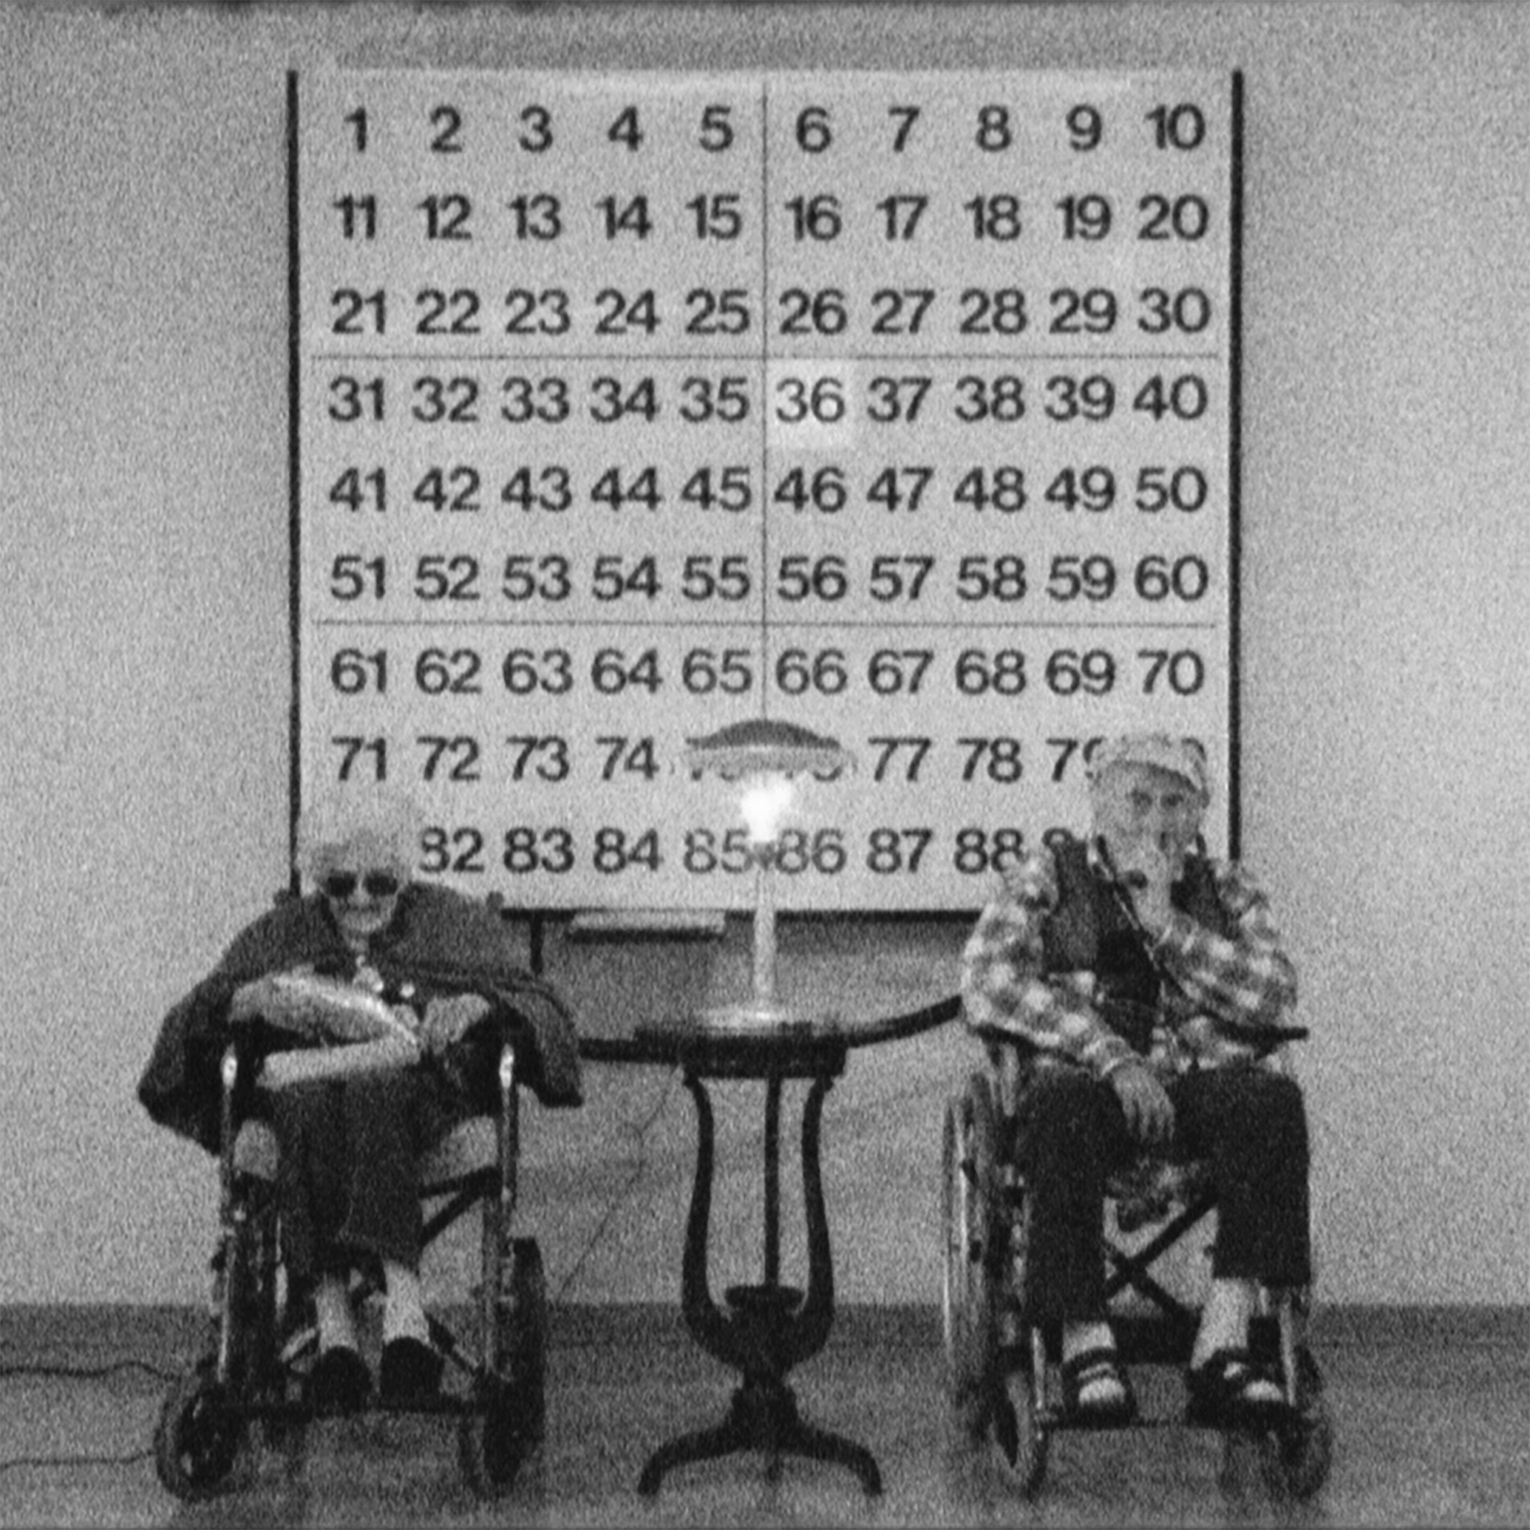

At 73rd Venice International Film Festival the latest work by Luca Ferri: Colombi is in competition for “Orizzonti” section, dedicated to new aesthetic and expressive tendencies. The film is produced by Lab 80 film and ENECE film.

20-minute long, shot in Super 8, the film tells of a love story that lasted almost one century: the main characters are two spouses, Annunciata Decò and Giovanni Colombi. Bound by a symbiotic relationship, the two go through the decades together and over the years they have a less and less dynamic relationship with the outer world, represented by the gradual change of common use objects and machines, such as motorcycles and coffee pot knobs.

With the usual, original style that typifies the films by Luca Ferri, the tale evolves among surreal images, colour and black and white alternation, transitions from gestures of love to narrations that almost remove any hope. Thus, Annunciata and Giovanni decide to withdraw more and more into themselves to silently rebel against the disappearance of ancient materials and the beauty of old objects, to the point of dedicating their lives leafing through animal encyclopedias in their sealed house.

The third character of the film is the unavoidable Dario Bacis, who often plays the leading role in Luca Ferri films: over 308 lbs of silence and compassionate inexpressiveness. In Colombi he becomes the author of small intervals which introduce the narration of the decades of the main characters, by means of an exotic feminine voice off. Alternating black and white and colour images, Bacis leads us between the joyous relationship of the elderly protagonists and their disillusion towards the outside world.

The director Luca Ferri explains: «Colombi is a reflection on the last century and two people's precise unwillingness to accept the changes imposed by society.
The film tells us about a pure feeling like love and leads us into an intimate universe made of small gestures and radical choices, in which isolation is the only way to survive».

Colombi confirms the vitality of the author Ferri, at his 14th cinematographic production in five years, and his ability to make his works different from one another, but always unexpected and visually unusual.

TRAILER
https://vimeo.com/161737069

PRESS MATERIALS (pressbook, pictures, poster)
http://www.lab80.it/pagine/colombi-di-luca-ferri-alla-mostra-internazionale-del-cinema-di-venezia-2016-una-storia-d-amore-e-dis

SCREENINGS AT VENICE INTERNATIONAL FILM FESTIVAL 2016

Thursday 1 September – Palabiennale, 1.30 pm
Thursday 8 September – Sala Giardino, 11 am
OFFICIAL SCREENING: Friday 9 September – Sala Giardino, 5 pm
Saturday 10 September – Sala Gardino, 11 am

Sara Agostinelli
Press office Lab 80 film
+39 329 0849615 +39 035 342239 +39 035 5781021
press@lab80.it www.lab80.it

